Install docker on EC2 and explore the docker commands (docker images, containers, volumes, network)

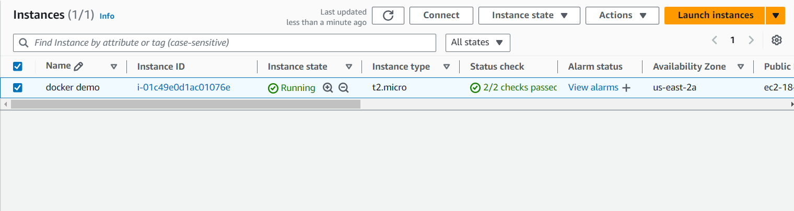

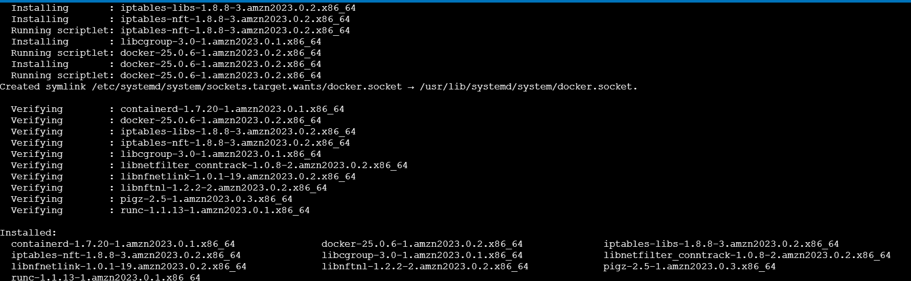

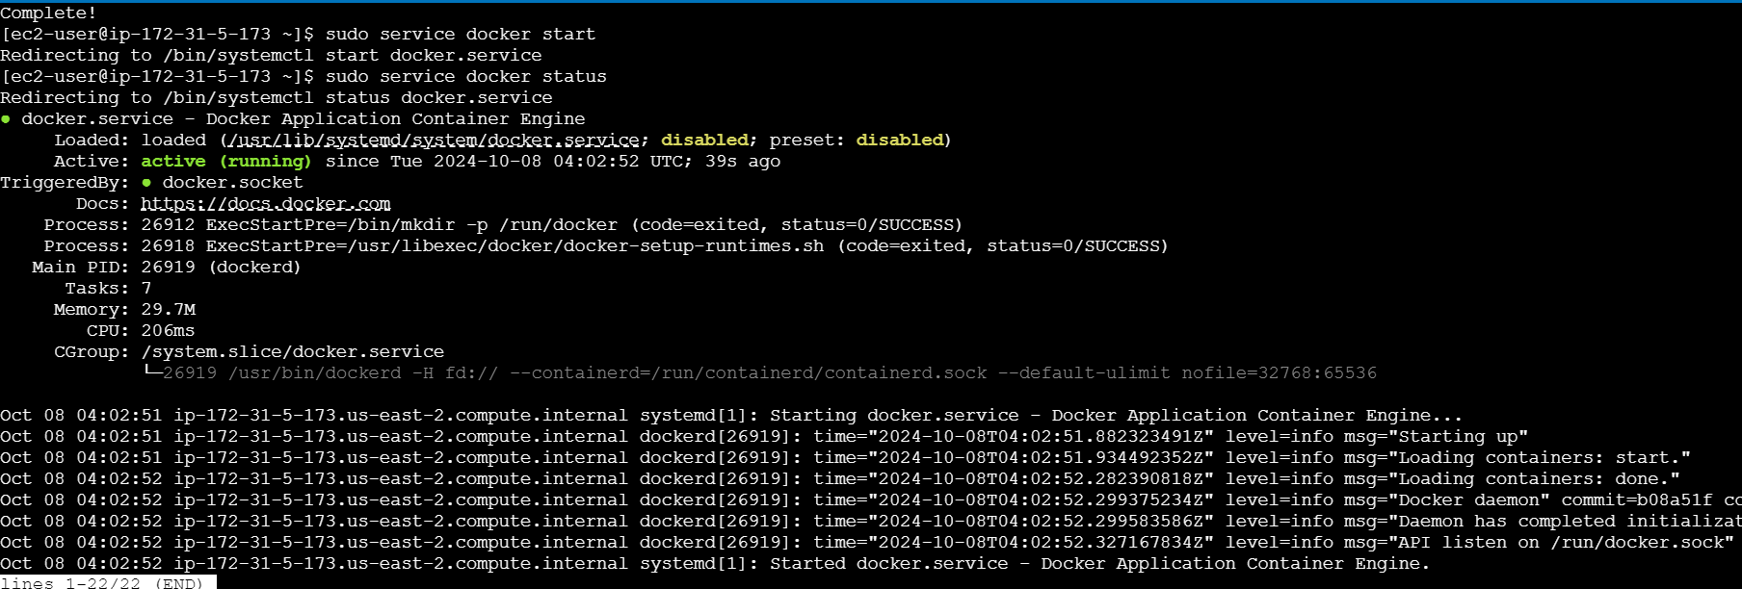

**Docker version:**

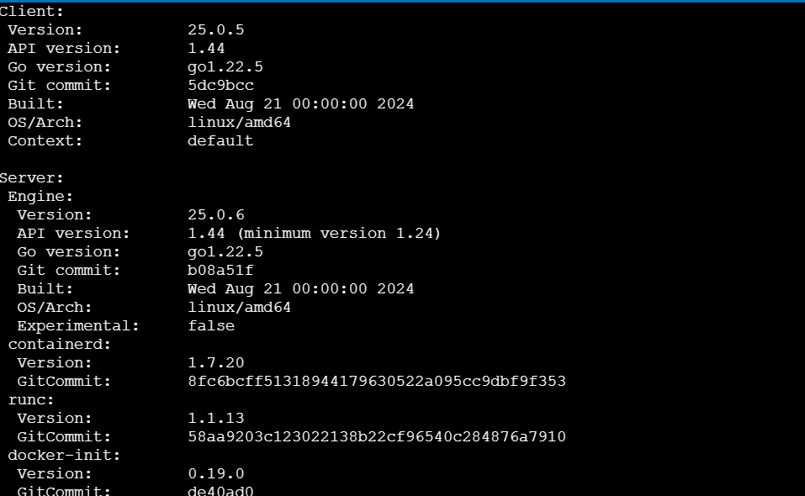

**Docker search nginx:**

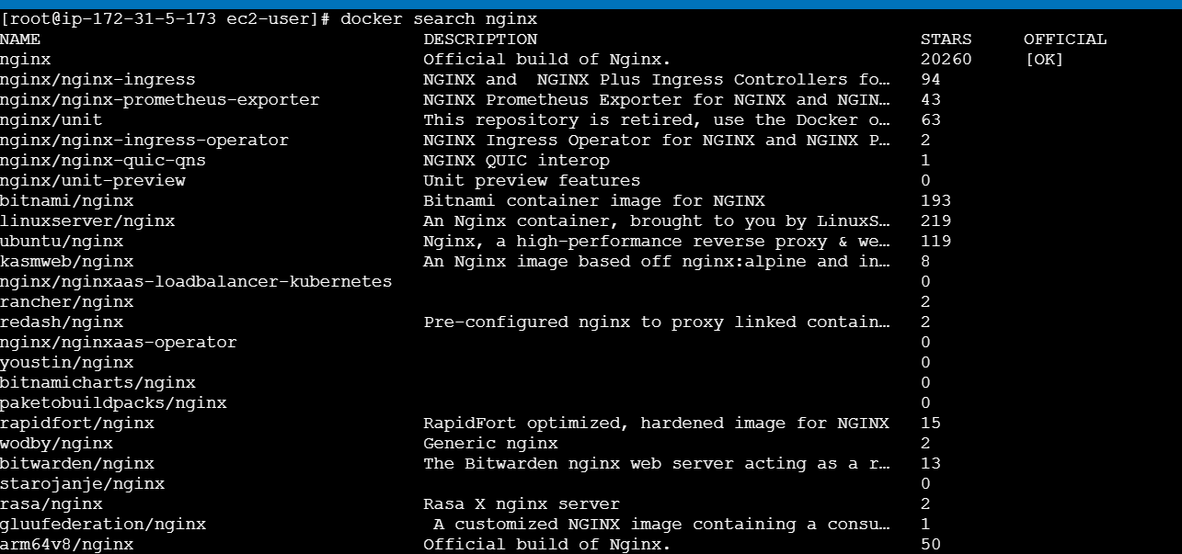

**Docker pull nginx:**

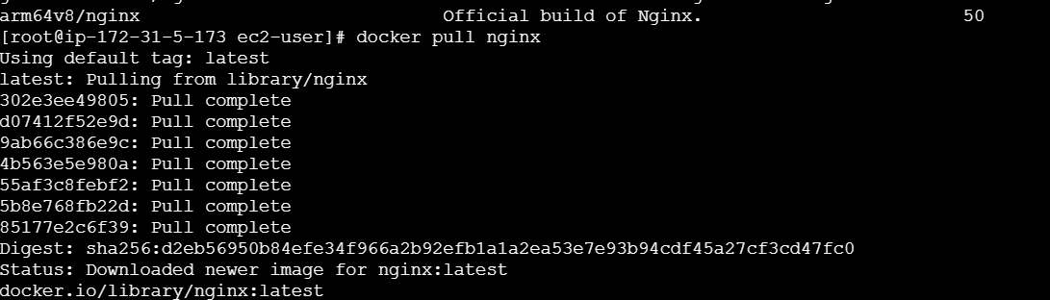

**Docker images:**

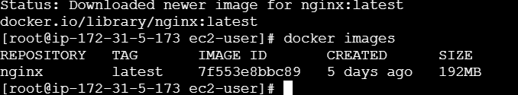

**Docker run nginx:**

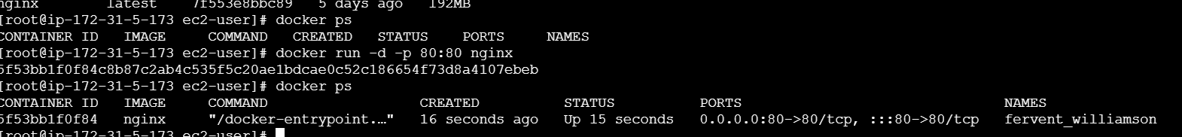

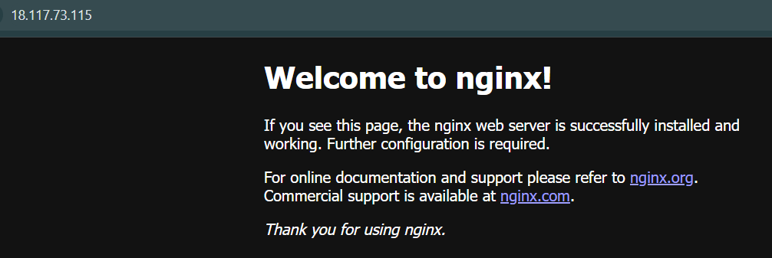



**Docker container id:**

